Colour Composing Fun

Create a song using a variety of items you can find around your house. Here are a few ideas you can use you will need 4 different ones from my kitchen you can even use some toys.
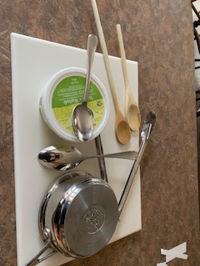

Choose a colour for each instrument. Colour a row of paint cans in each colour.
Arrange the paint cans on the blank composition page.
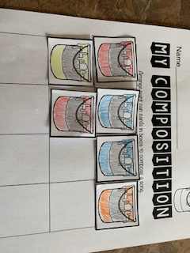
Try out your song! Have fun making music!
Send me a picture of a video of you and your family making music and I can post your picture on my webpage under the Music Fun Tab.

